[Table_Main]
Research Report
12 Jan 2026
GE Vernova (GEV US)

An energy transition leader well-positioned in the accelerating electricity investment supercycle: Initiation
s: Initiation
 |  | GE Vernova is a global leader in the electric power industry, specializing in products and services for generating, transferring, orchestrating, converting, and storing electricity. Spun off from General Electric in 2024, it builds on GE's legacy in electric power since 1896. Its installed base produces about a quarter of the world's electricity, aiding customers in energy transition. It operates in three segments: Power for gas, nuclear, hydro, and steam; Wind for onshore and offshore turbines; and Electrification for grid, conversion, solar, storage, and software. It is headquartered in Massachusetts with global manufacturing. Recent performance shows strong revenue growth, surging orders, and a record backlog, with Power as the top contributor and improving profitability.  Global electricity demand is surging from electrification, decarbonization, AI data centers, and industrialization, projected to double by 2050. In the U.S. and elsewhere, data centers drive rapid growth, but aging grids create bottleneck and delaying connections. This spurs demand for gas generators offering quick deployment and baseload reliability. Gas turbines in various categories lead the market alongside reciprocating engines, but supply constraints from cautious expansions, material shortages, and logistics have tripled plant costs and raised prices. Grid modernization requires trillions in investments to expand networks, integrating renewables and bidirectional flows via advanced software and hardware.  GE Vernova's upside hinges on backlog conversion with margin growth, acquisitions, and innovations. It targets backlog expansion to 200 billion dollars by 2028, driving revenue and margins higher with Power and Electrification leading. The Prolec GE acquisition by mid 26 will also boost Electrification through cross-selling and U.S. capacity. It is also investing key innovative products by developing SMRs, SOXC, SSTs,etc, which are potential significant value creator for the 2030s.  Valuation& recommendation  We estimate that revenue of GE Vernova from year 2025 to 2028 will be $36,938 / 41,553 / 48,460/56,709 million, with the net profit of $ 1,976 / 4,365/ 6,740/ 9,519million. Based on the DCF valuation model, our target price of GE Vernova is $ 862.93, we initiate coverage on the stock with “Outperform”.  Risks  Electricity demand below expectation; Changes in the regulatory environment; New entrants/technologies with cost-competitive products.
  [Table_Info]
  Initiate with OUTPERFORM
  Rating | OUTPERFORM
  Current Price
  Target Price
  Market cap
  Shares in issue
  1 yr high - low
  Note:
  Source: Company, HFI
  [Table_Profit]
   | Dec-24A |  | Dec-25E |  | Dec-26E |  | Dec-27E
  Revenue
  (+/-)
  Net Profit
  (+/-)
  EPS
  GPM
  ROE
  P/E
  Source: Company, HFI
[Table_Author]
Bin Yang
harryyang@hfisec.com.hk

Contents

1. GE Vernova: electrifying and decarbonizing the world 3
1.1 An equipment and services leader in energy transition 3
1.2 Financial performance highlights 11
2. Gas generators: A primary solution to global electricity demand growth, now facing acute supply constraints 13
2.1 Electrification and decarbonization catalyze global gas generator demand 13
2.2 Gas Generator Equipment Landscape Overview 15
2.3 Capacity bottleneck keeps the gas turbine up-cycle higher for longer 18
3. Growing need for transforming the aging grid to accommodate increasing complexity 20
3.1 Aging grid needs to be modernized 20
3.2 Increasing grid complexity requires software as well as hardware 21
4. GE Vernova is positioned to serve and win 22
4.1 More order backlogs feed into stronger revenue growth and margin improvement 22
4.2 Competing the Prolec GE acquisition by mid-2026 24
4.3 Developing and investing in new tech 24
5. Valuation& recommendation 26
6. Risks 28

- GE Vernova: electrifying and decarbonizing the world

1.1 An equipment and services leader in energy transition

GE Vernova Inc. is a global leader in the electric power industry, with products and services that generate, transfer, orchestrate, convert, and store electricity. The company was spun off from General Electric on April 2, 2024. While a new standalone entity, GE Vernova's focus on electrification and power can be traced to the early days of General Electric, which was a pioneer in electric power when it began trading in the Dow Jones industrial average in 1896.

Now with installed base generates approximately 25% of the world’s electricity, GE Vernova build, modernize, and service power systems to help customers electrify their operations and economies, meet power demand growth, improve system reliability and resiliency, and navigate the energy transition through limiting and reducing emissions.
Figure: Technologies of GE Vernova
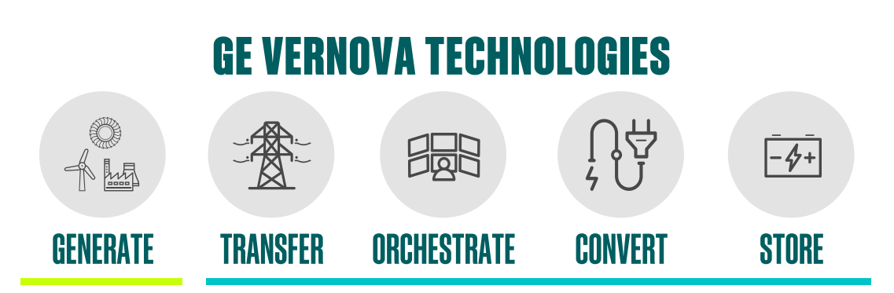
Source: Company, HFI
Sources of revenue for GE Vernova are split between the sale of equipment and services.

Equipment includes the design, manufacture, and delivery of a wide range of power generating, grid hardware and software, power conversion, and energy storage products. The company either sells products directly to customers or through engineering, procurement, and construction firms, where it can be either a sub-supplier or a consortium partner. The scope of supply can range from products alone to extended plant or project development scope, which can include plant-level guarantees and/or GE Vernova having turn-key responsibilities, often shared with partners, for project development. GE Vernova has manufacturing, assembly, and component production capabilities in nearly 100 plants across 27 countries.

Services includes the maintenance, replacement of spare parts, repairs, upgrades, and
software subscriptions throughout the operating life of products globally. Services are typically sold directly to customers, either through long-term contractual service agreements or as individual transactions at time of service. Long-Term Service Agreements dominate ~70–80% of service revenue with annual price escalation clauses and a weighted average remaining life ~7–9 years. The company invests in inspection and repair technologies, monitoring and diagnostics capability, and plant upgrade offerings to improve the performance and operation of the installed base.

GE Vernova operates in three segments: power, renewable energy, electrification.
Figure: BE’s revenue by segments and Non-GAAP gross profit by segments
Source: Company, HFI

Power Segment includes the design, manufacture, and servicing of gas, nuclear, hydro, and steam technologies, providing a critical foundation of dispatchable, flexible, stable, and reliable power. This segment delivers predictable and growing, long-term earnings and free cash flow from servicing vast installed base and from growing this installed base with new equipment and services. According to From 10 Filing in 2024, the company maintains the largest installed base of gas turbines globally of 886 installed GW and 2,206 GW total across its Gas Power, Nuclear Power, Hydro Power, and Steam Power businesses within this segment. In this segment, especially in gas turbines sub-segment, GE Vernova faces direct head-to-head competition from Siemens Energy and Mitsubishi Power. Other notable but smaller players in gas turbines include: Ansaldo Energia, Doosan, Baker Hughes, and Caterpillar (Turbines).
Table: Power segment main products
Main products |  | Descriptions
Gas Power | Equipment | Heavy-duty gas turbines ranging from 45 MW to more than 571 MW in size.  - the HA-class gas turbines (introduced in 2014, the HA fleet has surpassed 200 units ordered globally, with over 115 units already in commercial operation),  - the F-class gas turbines (1,400 turbines installed globally),  - the B/E-class gas turbines.  Aeroderivative gas turbines range from 34 MW to 116 MW in size and offer fast start times (as short as 5 minutes) with the capability to ramp up or down rapidly to quickly respond to variable and intermittent renewables
Gas Power | Service | Gas power plant technologies and services includes heat recovery steam generators, combined cycle steam turbine, generators, integrated turbine and plant control, digital solutions, decarbonization solutions.
Steam Power | Equipment | Industrial steam turbines.
Steam Power | Service | Support customers globally with spare parts repairs and services for existing coal steam turbines and generators
Hydro Power | Equipment | Pumped storage and new hydro plants consist of hydro turbines and generators designed and manufactured for use in hydroelectric powerplants powered from reservoirs with large dams or in run-of-river applications.
Hydro Power | Service | Hydro fleet services and modernization.  Hydro Power business has a 350 GW global installed fleet of hydro turbines and generators.
Nuclear Power | Equipment | GE Vernova, through its joint venture with Hitachi, Ltd., provides nuclear fuel products. GE Vernova owns a majority interest of the global business, outside of service operations in Japan, where Hitachi is the majority owner.
Nuclear Power | Service | Nuclear fuel services, nuclear reactor services and advanced nuclear reactor designs (“Nuclear Power Business”). The installed base of nuclear reactors that GE Vernova can service includes approximately 61 GW of Boiling Water Reactors

Source: Company, HFI

Figure: GEV gas turbine technology and selected offering specifications
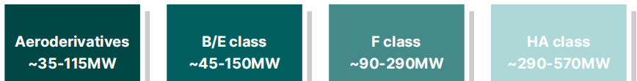
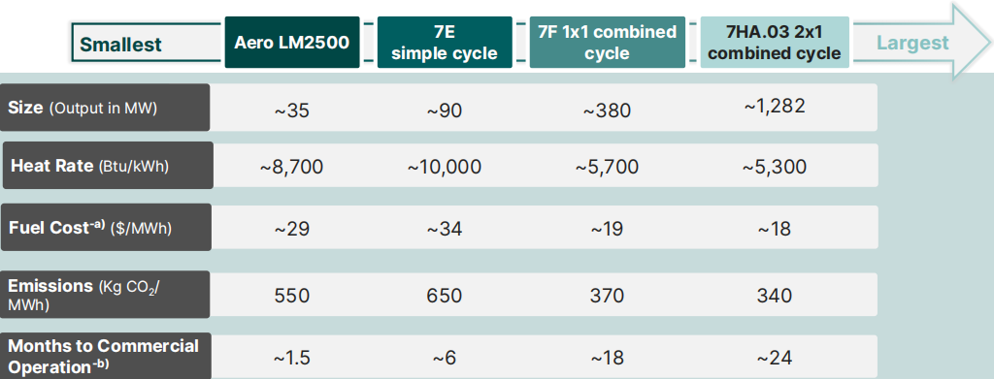
Source: Company, HFI
Table: GEV, ENR, and MHI GT business comparison
Feature | GE Vernova (GEV) | Siemens Energy (ENR) | Mitsubishi Heavy Industries (MHI)
Headquarters | Cambridge, MA, USA | Munich, Germany | Tokyo, Japan
Market Cap | ~$185 B | ~$135 B | ~$99 B
Gas Turbine Market Share (MW) | ~34%  (No. 1 in 2024/25) | ~24% | ~27%
Flagship Heavy-Duty Product | 9HA.01 / 9HA.02 | SGT5-9000HL | M701JAC (J-Series)
Aeroderivative Product | LM2500 / LMS100 | SGT-A35 (Rolls-Royce Tech) | FT4000 (Pratt & Whitney Tech)
Combined Cycle Efficiency | >64% (World Record Holder) | ~64% | >64%
Hydrogen (H2) Capability | 50% H2 capability today; pathway to 100% by 2030. | 100% H2 pilot successful | Target 100% H2 by 2030; leading in Ammonia firing.
Strategic Edge | AI-Power Play: Largest installed base in the U.S. and strong software integration. | Grid-to-Gen: Dominates the global transmission market (HVDC) along with Gas. | Reliability Leader: Consistently ranked No. 1 in "Advanced Class" market share by MW for several years.

Source: HFI

Wind Segments includes wind generation technologies with onshore and offshore wind turbines and blades. This segment benefits from secular demand tailwinds for zero-carbon power generation. GE Vernova maintains an installed base of 117 GW of Onshore Wind and 1 GW of Offshore Wind turbines for zero-carbon power generation. This segment is in competition with Vestas, Siemens Energy, Nordex, Goldwind, Envision, Mingyang and so on.
Table: Wind segment main products
Main products |  | Descriptions
Wind | Equipment | Onshore Wind: 3 MW onshore products; 6MW onshore products including high-output wind turbines.
Wind | Equipment | Offshore Wind: Haliade-X platform including offerings from 12 MW to 18 MW with estimated capacity factors ranging from 60% to 64%.
Wind | Equipment | LM Wind Power: Designs, produces, and tests turbine blades for use on wind turbines, as well as produce blades for sale to third-party OEMs
Wind | Service | Repower onshore/offshore/LM wind power products, remote monitoring, services, and upgrades

Source: Company, HFI
Figure: GEV installed generating capacity
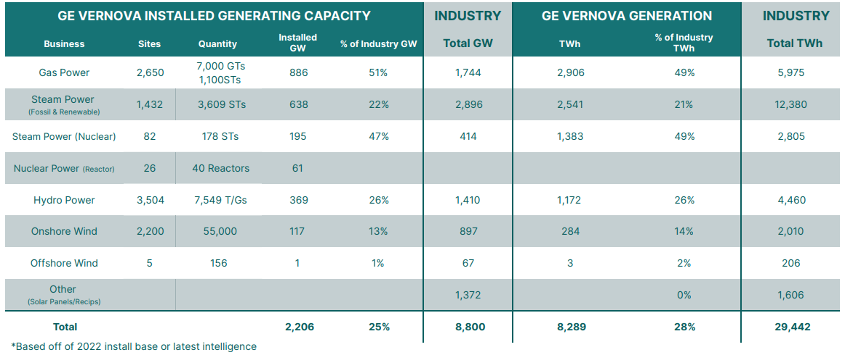
Source: Company, HFI

Electrification segment includes grid solutions, power conversion, solar and storage
solutions, which GE Vernova collectively refer to as Electrification Systems. And Electrification Software, including the digital technologies required for the transmission, distribution, conversion, storage, and orchestration of electricity from point of generation to point of consumption. This segment benefits from a growing need for grid infrastructure, modernization, and reliability, as well as from the demand for new products, solutions, and services. Investment in these technologies will be critical to enabling the energy transition by connecting renewables to the grid, electrifying other carbon-intense sectors, and preserving grid resilience and reliability.
This segment is in competition with Hitachi Energy, Siemens Energy, Schneider Electric, ABB, Eaton and so on.
Table: Electrification segment main products
Main products |  | Descriptions
Electrification | Equipment | Electrification Systems: Grid solutions, power conversion, solar and storage solutions like high voltage direct current transmission, or HVDC, products, power transformers.
Electrification | Equipment | Electrification Software: GridOS® Digital technologies required for power transmission, distribution, conversion, storage etc.
Electrification | Service | Service and solution regarding electrification.

Source: Company, HFI
Figure: Electrification focus
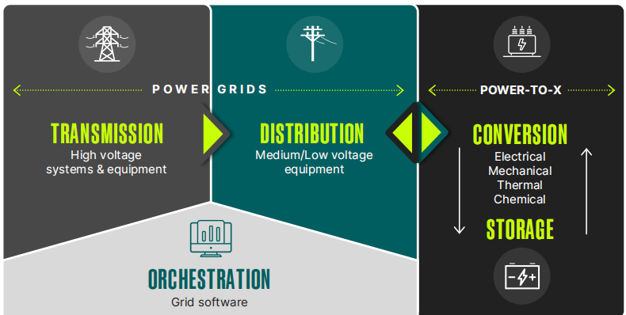
Source: Company, HFI

GEV serves the most impactful electricity providers in key markets. Notable customers include major international utilities and energy companies such as Iberdrola, Enel, ENGIE, RWE, Southern Company, Duke Energy, KEPCO, Taiwan Power Company, and Hydro Québec. This immense reach is driven by a deep integration with the industry's largest players. GEV's 20 largest customers generate roughly 40% of the electricity within their respective geographic regions. In both the United States and Europe, 9 out of 10 of GEV’s top-10 customers transact with six or more of its distinct business units, demonstrating a broad reliance on GEV’s full suite of power, wind, and electrification solutions.

Figure: GEV maintains a highly diversified and globalized presence
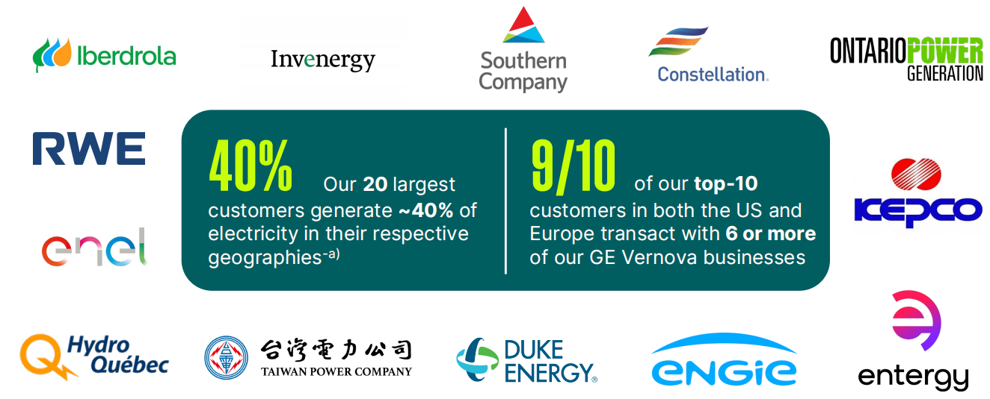
Source: Company, HFI

GE Vernova is headquartered in Cambridge, Massachusetts and occupies approximately 600 sites in 465 cities and 95 countries.

GE Vernova operates 91 manufacturing sites globally, 18 in the United States and 73 internationally. In December 2025, the company announced that its gas power segment is operating at full capacity, with gas turbine production fully booked through 2028 and only limited slots remaining for 2029. This strong demand has accelerated GE Vernova’s capacity expansion: the company has advanced its target to reach 20 GW of annual gas turbine manufacturing capacity by mid-2026 (originally planned for Q3 2026) and further raised its long-term goal to 24 GW annually by mid-2028. Meanwhile, the Electrification segment is also experiencing unprecedented demand, contributing to a record backlog across the business. The manufacturing facilities are used by GE Vernova's segments as follows:
Table: Main manufacturing facilities
By segment |  | By region
Power | 38 | Americas | 29
Wind | 19 | ASEAN | 25
Electrification | 34 | EMEA | 37

Source: Company 2024 Form 10-K, HFI
GE Vernova is led by an executive team focused on the global energy transition following its successful spin-off from General Electric in 2024. The management is headed by Scott Strazik, who serves as Chief Executive Officer, bringing extensive leadership experience from his previous roles within GE's power and energy divisions. He is supported by a specialized leadership structure divided into core segments: Vic Abate serves as CEO of Wind, Mavi Zingoni as CEO of Power, Philippe Piron as CEO of Electrification Systems, and Scott Reese as Electricifation Software. Financial operations are overseen by CFO Kenneth Parks, while Pablo Koziner leads as Chief Commercial Officer. The corporate governance is further strengthened by an independent Board of Directors chaired by Stephen Angel.

Figure: Leadership Team
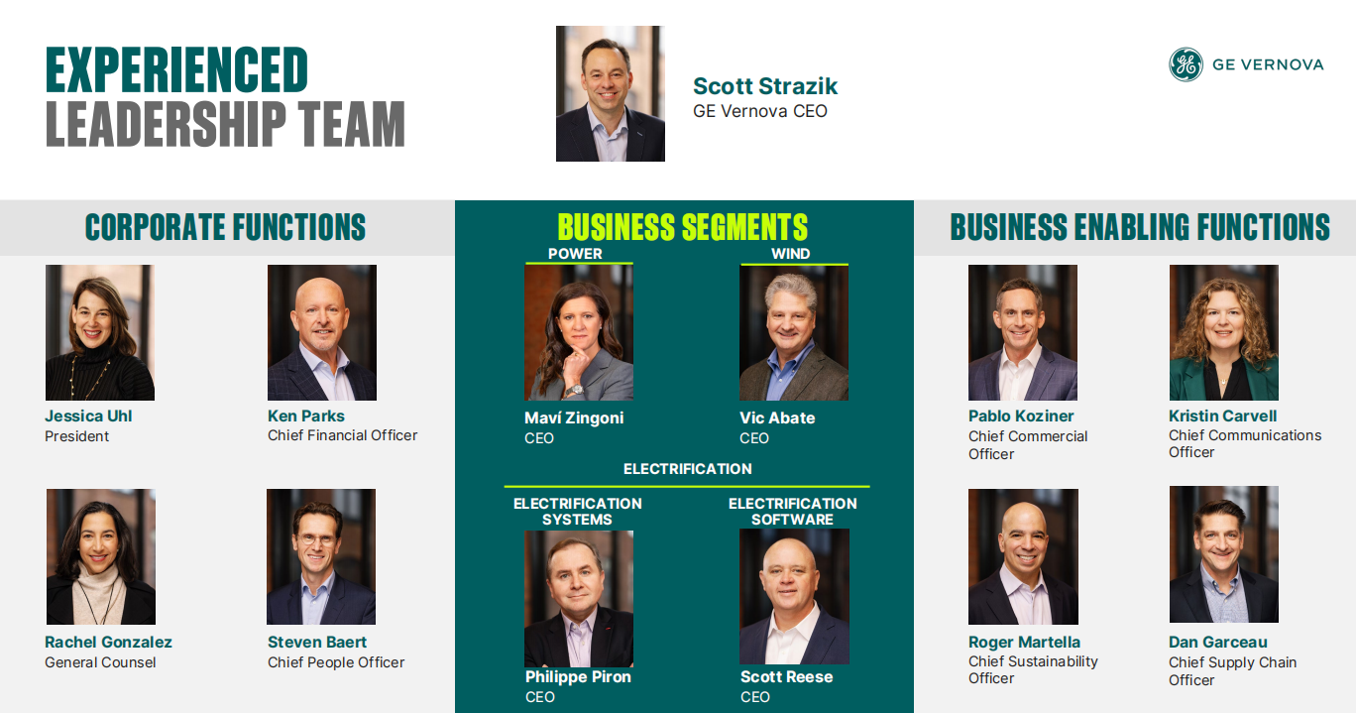
Source: Company, HFI
With its talented management, GE Vernova implements its Lean operating system by embedding SQDC (Safety, Quality, Delivery, and Cost) as the foundational compass for all global operations.

Figure: GE Vernova lean operating system
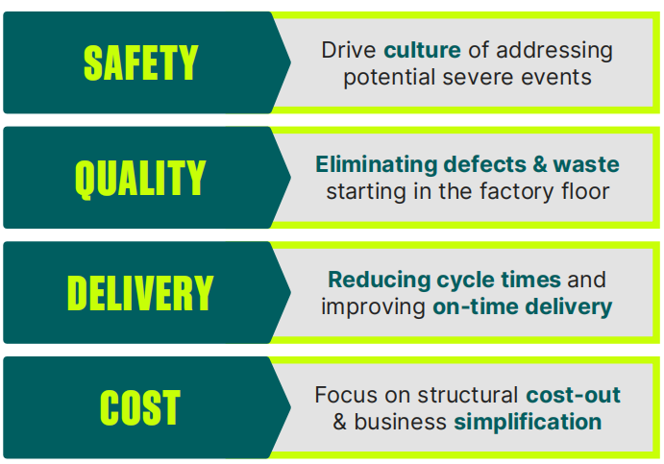
Source: Company, HFI

1.2 Financial performance highlights
GE Vernova continued its strong upward trajectory through Q1-Q3 2025, reporting total year-to-date revenue of more than $27 billion, an 11% increase over the same period in 2024. This growth was anchored by a massive surge in orders, which jumped 55% in Q3 alone, bringing the total backlog to a record $135.3 billion.

The Power segment remains the largest revenue contributor, generating $14.02 billion YTD. Performance was bolstered by a supercycle in Gas Power, where equipment orders increased by 50% in the third quarter. The company now holds 62 GW of gas power equipment in its backlog and slot reservations, reflecting a high demand for reliable baseload power.

The Electrification segment has emerged as the company’s primary growth engine. Revenue for the segment reached $6.68 billion through September, driven by a 35% surge in Q3 revenue. Demand for grid solutions and transformers, fueled by the global expansion of AI data centers has pushed the electrification equipment backlog to approximately $26 billion.

In contrast, the Wind segment reported YTD revenue of $6.74 billion. While Onshore Wind deliveries remain steady, the segment overall saw a revenue decline of 8% in the most recent quarter. Management remains focused on a “lean” turnaround for Wind, expecting the business to approach profitability in the second half of the year as supply chain constraints and legacy offshore project costs begin to subside.
Figure: GEV’s revenue by segments and segment revenue breakdown
Effective January 1, 2025, our Power Conversion and Solar & Storage Solutions business units within Electrification segment were combined to form a new business unit, Power Conversion & Storage
Source: Company, HFI

The profitability keeps a strong improving momentum. The company as a whole achieved an 8.1% adjusted EBITDA margin in Q3 2025.

Power segment remains strong in profitability, reporting a segment EBITDA margin of 13.3% in Q3 2025. The strong demand for gas power equipment and services, driven by 20 heavy-duty units ordered in the quarter, bolstered this performance.

The Electrification segment showed strong and expanding profitability with a segment EBITDA margin of 15.1% in Q3 2025, up significantly from the previous year. This improvement was driven by higher volume, price, and productivity across grid solutions and power conversion.

The Wind segment is still operating at an operational loss but has shown significant improvement, with an EBITDA margin of -2.3% in Q3 2025. This marked an improvement from the -7.9% margin in Q1 2025, with management continuing its "lean" turnaround strategy. However, we expect the operational challenges in permitting, tariffs, and project execution significantly will continue to affect the prospects of the wind segment.
Figure: GEV’s GM breakdown
Source: Company, HFI

Figure: EBITDA margin by segment
Source: Company, HFI

Gas generators: A primary solution to global electricity demand growth, now facing acute supply constraints

2.1 Electrification and decarbonization catalyze global gas generator demand
Global electricity demand is surging as economies accelerate the shift from direct fossil fuel combustion to electrification in pursuit of net-zero emissions. This transformation, fueled by climate commitments, national security imperatives, and economic competitiveness, is being supercharged by several powerful trends: the explosive growth of AI and energy-intensive data centers, rapid industrialization and re-industrialization, and the widespread “electrification of everything.” From electric vehicles transforming transportation to heat pumps decarbonizing heating in homes and businesses, electricity is becoming the backbone of modern energy systems. According to the International Energy Agency (IEA), global electricity consumption is on track to double by 2050 compared to 2024 levels, underscoring the urgent need for massive investments in generation, transmission, and grid infrastructure.

Figure: Electricity consumption increasing ~2X by 2050
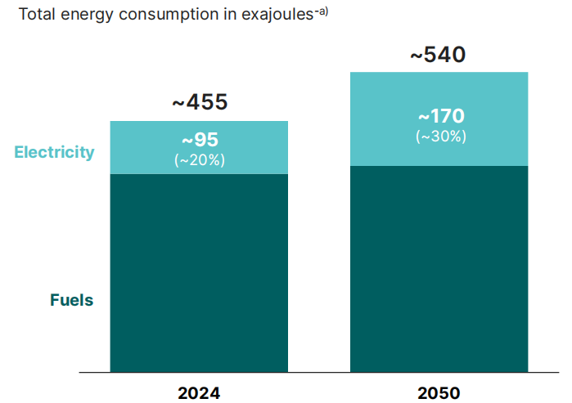
Source: IEA World Energy Outlook 2025, HFI

In particular, US electricity demand is surging at a historic pace, with the U.S. Energy Information Administration (EIA) forecasting an additional 90 TWh in 2026 alone, ending two decades of stagnation. This growth is driven primarily by AI and cloud-based data centers, which are projected to consume up to 12% of national electricity by 2030, up from just 4% today. However, a massive transmission gap has emerged. While utilities can generate enough power, aging and insufficient grid infrastructure cannot transport it. At current construction rates, the U.S. Department of Energy warns it could take 80 years to build the high-voltage transmission lines needed for the next decade, drastically delaying new facility connections.
Figure: US interconnection wait times at key ISOs (years)
Source：Everus Power &Renewable, HFI
Consequently, gas generators are in high demand, especially as data center developers increasingly compete with utilities to secure on-site power generation. In today’s energy boom, gas power is leading the way, offering rapid deployment, high power density, and baseload reliability, making it uniquely suited for data centers where speed-to-market is critical. According to Semianalysis, a single gigawatt of AI infrastructure can generate $ 10 to12 billion in annual revenue. In that context, bringing a 400 MW data center online just six months earlier can be worth several billion dollars in accelerated revenue.

This surge is driving strong demand for both aeroderivative and smaller gas units as bridge power, and heavy-duty gas turbines for reliable baseload—especially across North America. While alternatives like co-location with existing nuclear plants, onsite SMRs, or geothermal exist, most are not expected to contribute meaningfully to net new power generation over the next three years.

Surging demand for gas generators is also true almost everywhere else, with countries around the world accelerating their demand for gas power. Governments are strategically moving away from vulnerable or expensive energy sources to bolster energy independence, natural gas power remains a preferred strategic choice due to its unique role in ensuring operational reliability and sovereign stability:

- Europe: Aggressively transitioning from coal to gas and renewables to decouple from geopolitical supply risks.
- Middle East: Shifting from oil to gas and solar to free up crude oil for higher-value exports.
- Taiwan: Pivoting from nuclear to gas and offshore wind to manage its unique baseload challenges while sustaining its energy-intensive semiconductor industry.

Figure: Orders for utility-scale natural gas turbines
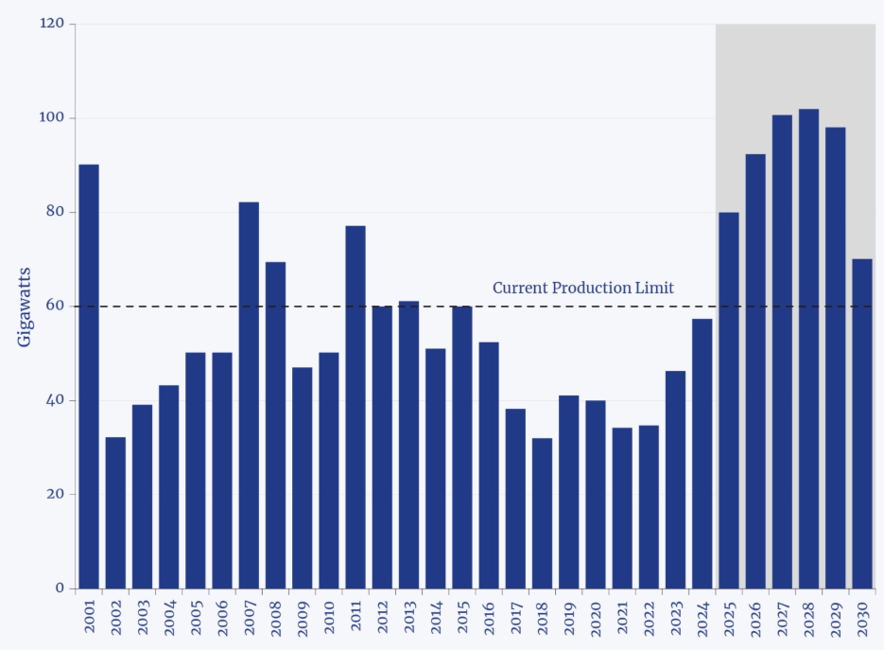
Source: Bloomberg Green, HFI

2.2 Gas Generator Equipment Landscape Overview
Among gas generators available to data center developers, there are three broad categories:
- Gas Turbines (GTs)
- Reciprocating Internal Combustion Engines (RICEs).
- Solid-oxide fuel cells (SOFCs) - for this, please refer to our reports on Bloom Energy for more information.

Below is a table summarizing the of attributes of multiple gas generator technology:
Table: Attributes of multiple gas generator technology
Tech | Size per Unit | Lead Time | Start Time to Full Load | Land Use | Electrical Efficiency | Est. LCOE w/ Maintenance
 | MW | Months | Minutes | MW/acre | % | $/MWh
H-Class CCGT | 600-1000 | 36-60 | 30-60 | 20-30 | 50-60% | 100-200
Small CCGT | 40-100 | 18-36 | 30-60 | 20-30 | 40-55% | 85-160
Aeroderivative GT | 30-60 | 18-36 | 10 | 30-50 | 35-40% | 80-130
Industrial GT | 5-50 | 12-36 | 20-30 | 20-40 | 35-40% | 65-110
Medium-Speed RICE | 7-20 | 15-24 | 5-10 | 8-15 | 40-50% | 80-150
High-Speed RICE | 3-5 | 15-24 | 5-10 | 5-10 | 40-50% | 120-200

Source: Semianalysis, HFI

- Gas Turbines

These systems compress ambient air, mix it with fuel for high-temperature combustion, and use the resulting high-pressure exhaust to spin a turbine connected to a generator. In a combined-cycle gas turbine (CCGT), this exhaust heat is captured to produce steam that drives a secondary turbine—boosting overall efficiency to over 60%.

Heavy-duty CCGTs

- Categories:
- E/F-Class (mature, lower-cost): GE Vernova 6B/7E, Siemens SGT6-2000E
- H-Class (high-efficiency): GE HA, Siemens H/HL, Mitsubishi Power J-Series
- Pros:
- 50-64% efficiency via waste-heat recovery in combined-cycle mode
- Low emissions (vs. coal/oil), hydrogen-ready (up to 30% in new models)
  - Reliable baseload power with 30+ year lifespan and grid stability support
- Cons:
- High Capex, ~2-year build time, and long equipment lead times
- Large footprint, low modularity, and slow startup (>30 mins)

Figure: GE Vernova 9HA turbine
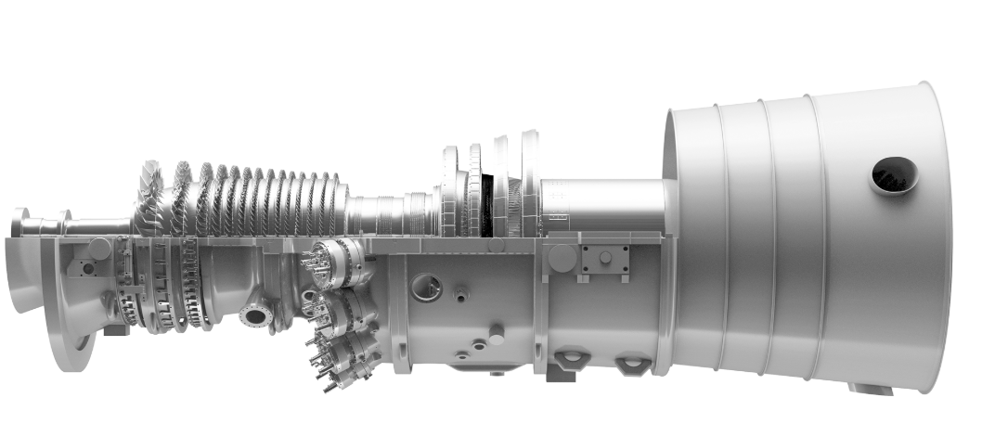
Source: Company, HFI

Aeroderivatives

- Features: Derived from aircraft jet engines (e.g., GE Vernova LM6000), highly modular, and designed for rapid deployment.
- Pros:
- Fast startup (5–10 minutes) and ～40% efficiency in simple-cycle mode
- Quick installation—often commissioned in 2–4 weeks
- Compact footprint and fuel flexibility (natural gas, diesel, biofuels)
- Cons:
  - Rising lead times (18–36 months)
  - Higher operating and maintenance costs compared to heavy-duty units
  - Limited scalability for large baseload applications

Figure: GE Vernova LM2500 turbine
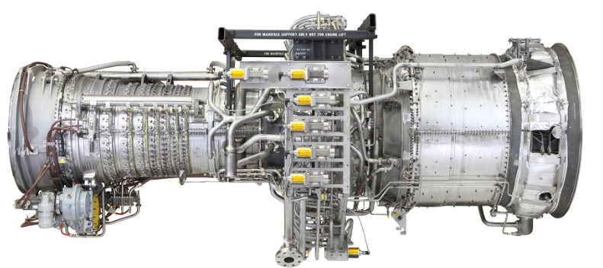
Source: Company, HFI

Industrial gas turbines

- Features: Simpler, rugged design based on the same cycle as aeroderivatives but with lower turbine inlet temperatures. Key suppliers: GE Vernova, Siemens Energy, Mitsubishi Power, and Caterpillar (Solar Turbines).
- Pros:
  - Smaller footprint than heavy-duty units
  - Lower maintenance costs due to simpler design and cooler operation
- Cons:
  - Lower efficiency (~35–40%) and slower ramping than aeroderivatives
  - Lead times of 12–36 months

Figure: Caterpillar’s subsidiary Solar Turbines’ Titan 130
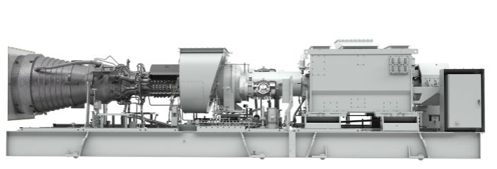
Source: CAT Company, HFI

- Reciprocating Internal Combustion Engines (RICE)

These engines ignite a fuel-air mixture in cylinders to drive pistons, converting linear motion into rotational energy via a crankshaft to power an alternator.

- Categories:
  - High-speed (~1,500 rpm): Compact; key players include INNIO Jenbacher, Caterpillar, Cummins, and MTU (Rolls-Royce).
  - Medium-speed (~7750 rpm): More robust and durable; led by Wärtsilä, Bergen Engines (Tognum/ Rolls-Royce), and MAN Energy Solutions.
- Pros:
  - Highest simple-cycle efficiency (～48–50%)
  - Excellent part-load performance and ultra-fast ramping (full load in <5–10 minutes)
  - Highly modular and fuel-flexible (natural gas, biogas, hydrogen blends)
- Cons:
  - Medium-speed units are heavy, require reinforced foundations, and take ～10 months to install
  - Lead times average 15-24 months across both categories due to strong demand

Figure: Caterpillar’s G3516 TA Gas Engine
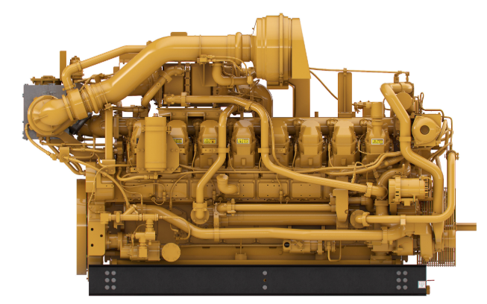
Source: CAT Company, HFI

2.3 Capacity bottleneck keeps the gas turbine up-cycle higher for longer

While the demand of gas turbines are surging, capacity expansion are cautious. The demand for all sorts of gas turbines are rising. However, most manufacturers are responding with cautious capacity expansion, not a full-send buildout.

Table: capacity targets for the major gas turbine manufacturers
Manufacturer | Production Target & Capacity
GE Vernova | Increase to 24 GW/year by mid-2028 (vs. ~11–12 GW in 2024).).
Siemens Energy | Scale from ~20 GW to >30 GW by 2028–30.
Mitsubishi (MHI) | Double turbine capacity to meet surging demand..
Caterpillar (Solar) | Double engine production; 2.5x turbine production by 2030.
Wärtsilä | Incremental expansion only.

Source: iFind, HFI

The cautiousness come from manufacture's institutional memory of the Y2K gas turbine boom and recent memory of generationally low sales. Since the mid-1990s, the gas turbine industry has endured two distinct boom-bust cycles:

Table: The Two Boom-Bust Cycles of Gas Turbines
The Two Boom-Bust Cycles of Gas Turbines
1. The Dot-Com Surge (1997–2002) | Driven by U.S. deregulation and inflated demand forecasts from the tech bubble, giants like GE and Siemens saw "lunar" order volumes. GE’s shipments peaked at over 60 GW in 2001. The crash was swift, triggered by the dot-com collapse and the Enron scandal, leading to a multi-year "manufacturing winter."
2. Stabilization and Slump (2006–2022) | After a decade of steady shipments (averaging 20 GW/year for GE and 15 GW/year for Siemens), the market bottomed out. Between 2017 and 2022, both companies hit generational lows, with production dropping below 10 GW/year.

Source: Semianalysis, HFI

Figure: Annual US simple-cycle gas turbine power plant capacity additions
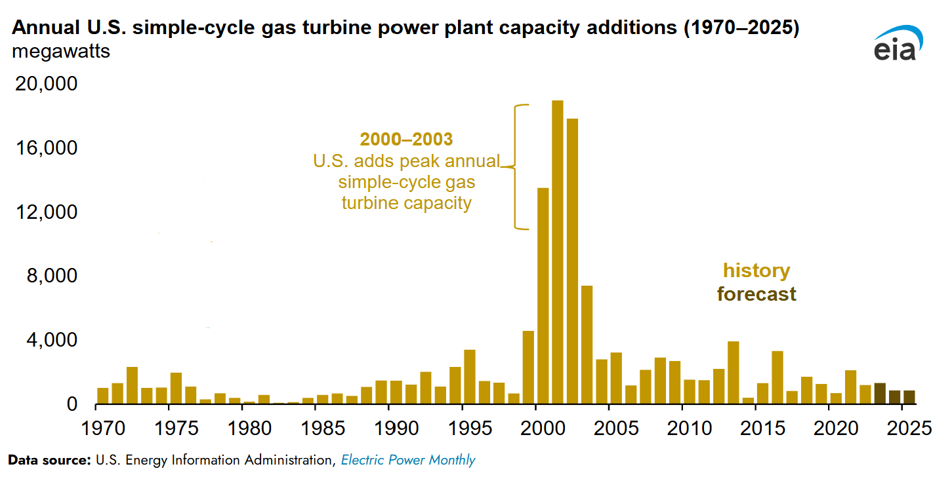
Source: EIA, HFI

Additionally, production of heavy-duty gas turbines is severely constrained by both supply chain bottlenecks and logistical hurdles. The specialized market for turbine cores is concentrated among four Western firms—PCC, Howmet, CPP, and Doncasters—who must balance industrial demand against civilian and military aerospace needs while managing volatile supplies of rare materials like rhenium and cobalt. Vulnerable to market shocks and wary of a potential AI bubble, these suppliers are hesitant to expand the specialized workforce and infrastructure needed to increase output.

Furthermore, the massive physical scale of these 300-500-ton systems necessitates complex transport via specialized barges and rail, resulting in a 24-30 month commissioning timeline. While smaller aeroderivative and industrial turbines offer more flexibility by shipping in standard containers, the heavy-duty units essential for large-scale power remain tethered to these rigid manufacturing and logistical limits.

Figure: Siemens SGT5-800H H-Class turbine on a self-propelled modular transport
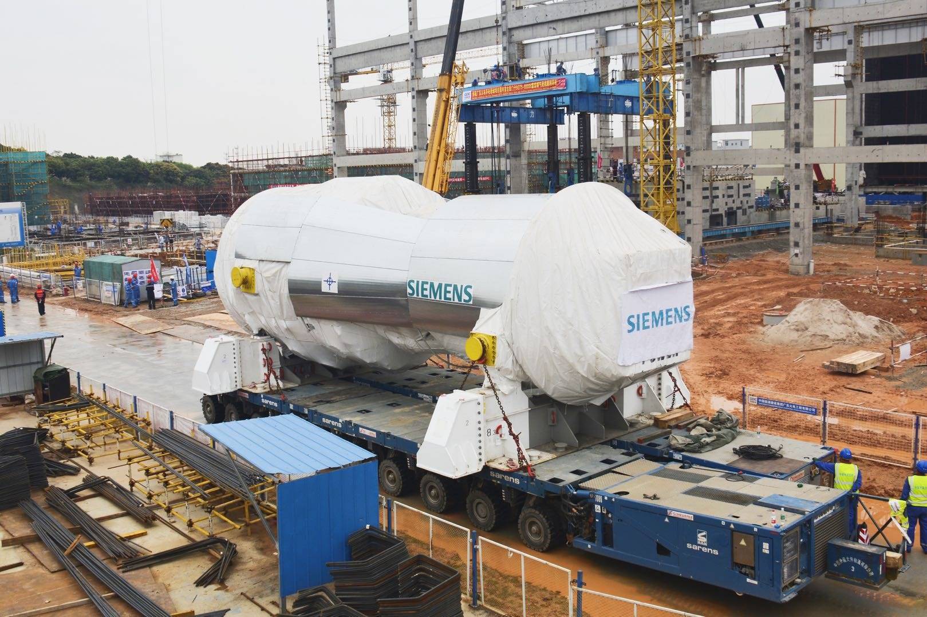
Source：Siemens, HFI

As a result, the cost of building gas-fired plants is soaring. Since 2022, the price of a full-scope combined-cycle gas-turbine plant has more than tripled, rising from less than $800/kW to as much as $2400/kW, driven by turbine scarcity, HRSG/transformer backlogs, and EPC/labor constraints. Based on our calculation, the GE Vervona’s GTs equipment order price increased from ~$400/ kW on average in the end of 24 to more than $600/kW in 3Q 25.

Figure: GEV’s Power equipment order price per kW
Source：Company, HFI

Growing need for transforming the aging grid to accommodate increasing complexity

3.1 Aging grid needs to be modernized

Aging grid needs investments. The electrical backbones of the world’s most advanced economies are reaching their breaking point. In the United States, roughly 70% of transmission and distribution lines are well into the second half of their 50-year life expectancy. Similarly, in Europe, approximately 40% of the power distribution networks are over 40 years old. Aging grids are increasingly susceptible to extreme weather, with wildfires in the U.S. and heatwaves in Europe leading to systemic failures. The International Energy Agency (IEA) warns that failing to modernize will lead to systemic gridlock. Additionally, while infrastructure withers, demand is undergoing a historic surge driven by the AI Revolution, Re-Industrialization, and Society-Wide Electrification. Therefore, investments are needed to revitalize the grid.

According to Mckinsey, the world is projected to invest $106 trillion in infrastructure projects across all sectors by 2040. More than 50% of total investment will go to the energy and transport sectors, where legacy systems are struggling to keep pace with a digital economy. The IEA reports that to meet national climate and energy goals, the world must add or refurbish over 80 million kilometers of electrical grids by 2040, a distance equivalent to the entire existing global grid today. This means a huge necessary investment into grid systems integration (HVDC systems and substations), power transmission (switchgear, transformers, and circuit breakers), power conversion & storage (critical products such as synchronous condensers).

Figure: Infrastructure Investment by 2040
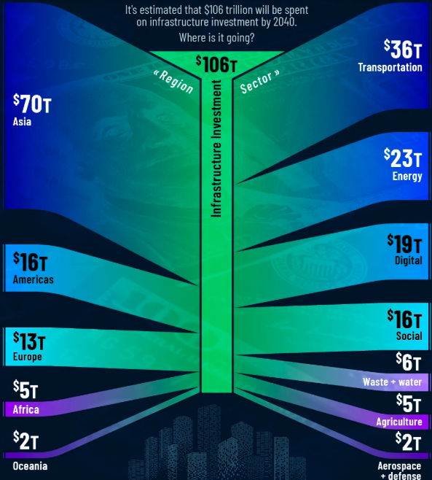
Source: McKinsey, HFI

3.2 Increasing grid complexity requires software as well as hardware
Increasing grid complexity requires smart software to coordinate and automate because the modern grid is a multidimensional network of thousands of different inputs and the sheer volume of real-time data and the speed of fluctuations have surpassed what human operators can manage manually. With the integration of intermittent renewable sources like wind and solar, the supply of electricity is no longer constant. Software acts as the brain of this system, using predictive algorithms and artificial intelligence to forecast these changes and balance them against the surging demand from electric vehicles and smart buildings.

Furthermore, the shift toward a decentralized network means that energy now flows bidirectionally. Prosumers, homeowners and businesses that both draw from and feed back into the grid, create a highly volatile environment where the grid must constantly adjust to prevent overloads or blackouts. Advanced software solutions, are required to orchestrate these thousands of micro-transactions simultaneously. This technology ensures that power is routed where it is needed most in real-time, effectively turning a chaotic web of independent energy sources into a stable, reliable utility.
Figure: Increasing grid complexity requires software
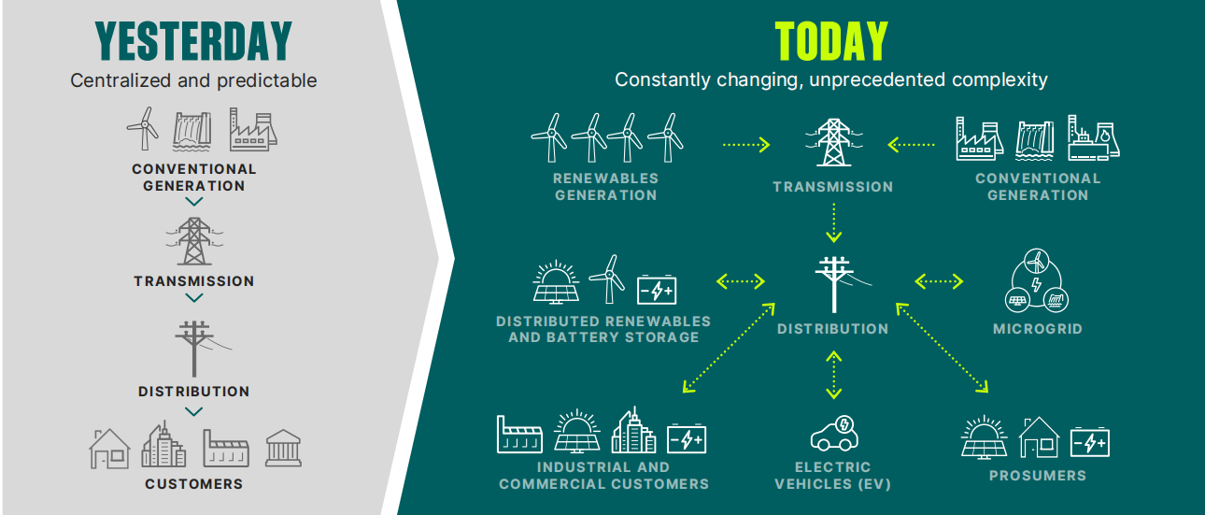
Source：Company, HFI

GE Vernova is positioned to serve and win

More order backlogs feed into stronger revenue growth and margin improvement

We believe as GE Vernova ships equipment and performs services, huge pile of backlogs convert into huge revenue. GE Vernova currently has a total backlog of approximately $ 135 billion ($ 54 billion in equipment and $ 81 billion in services) and plans to grow it to $ 200 billion by 2028, with both Gas Power equipment and Electrification backlogs expected to double by that year. As the company progresses toward ramping up its annual gas turbine capacity to 20 GW by mid-2026 and approximately 24 GW by 2028, its substantial backlog provides strong visibility into future revenue, with a significant portion expected to convert into confirmed sales. The company now is expecting revenue up high teens at Power & Electrification, down LDD at Wind in 26 and LDD revenue CAGR from 25 to 28 with. We believe as the global power demand surging and grid modernization need continuing, GE Vernova are expect to pile up more order backlog, especially for its Power and Eletrification segment.
Figure: GEV’s equipment backlogs in 2025 Q3 and estimated total backlogs in 28
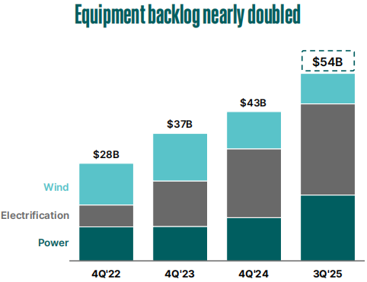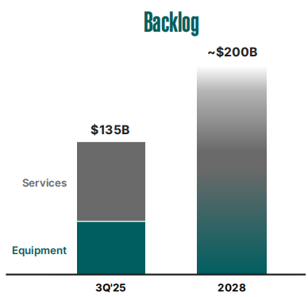
Source：Company, HFI

Besides the topline expasion, GE Vernova is focused on disciplined underwriting, meaning they are only adding high-margin projects to the pile. We believe the margin improvement will come from stronger pricing power and higher productivity through lean manufacturing. Newer orders in the backlog are being signed at higher prices than the ones they are currently delivering. As older, lower-priced contracts are completed and replaced by these new high-price contracts, profit margins naturally expand. The Adj. EBITDA margin of the company is expected to be 11%-13% in 26, and at least 20% by 28. It is worth mentioning that a large portion of the backlog is for long-term Services. Service contracts typically have much higher margins (often 25%+) than equipment sales. Now the company has already seen the higher upgrade demand in services and strong price escalation on both existing service contracts and new service contracts as gas installed base grows.

Figure: Incremental strength in revenue and margin in Power & Electrification
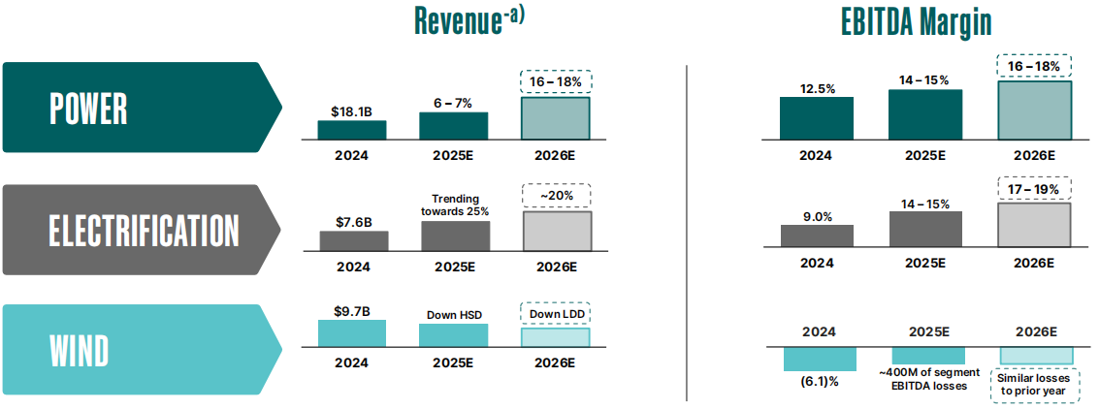
Source：Company, HFI
Figure: Continued margin expansion in 2026
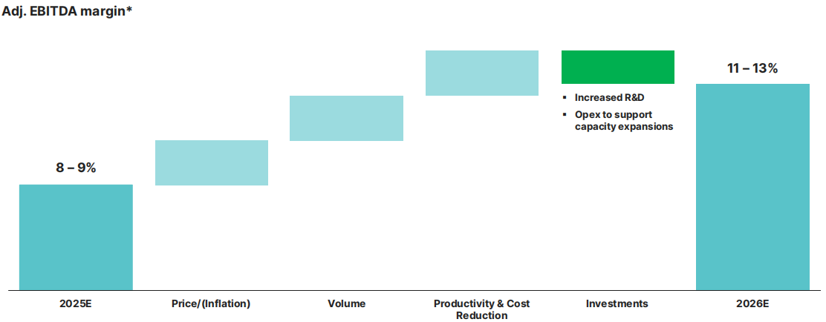
Source：Company, HFI

Figure: GEV’s 2028 Outlook
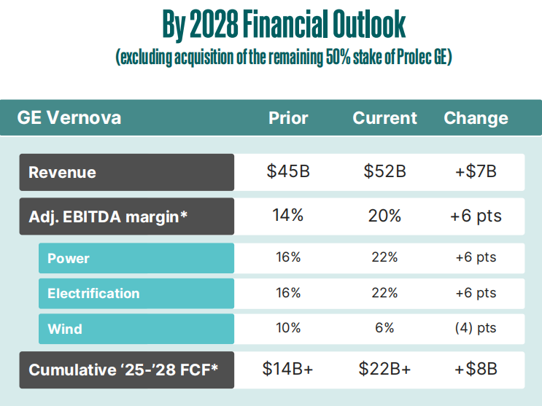
Source: Company, HFI

4.2 Competing the Prolec GE acquisition by mid-2026

We believe competing the Prolec GE acquisition by mid-2026 is reinforcing GE Vernova’s Electrification segment as a growth engine. Prolec GE is a leading manufacturer of power and distribution transformers, particularly known for its expertise in liquid-immersed (oil-filled) transformers. It has ~$4 billion equipment backlog as of 2Q25 and a expected LDD revenue CAGR from 25 through 28. In October 25, GE Vernova announced its plan to acquire the remaining 50% stake in Prolec GE.

Previously, as a joint venture, there were contractual limits on how GE Vernova and Prolec could compete or collaborate (e.g. GE cannot compete in the mid-tier and distribution transformer segment in North America). Full ownership removes these restrictions, and allows cross-sell plays to customers of both Prolec GE and GEV, offering a complete transformer portfolio from distribution to EHV transmission. GE Vernova can also utilize GEV transformer factories outside of the U.S. to deliver more volume into the US. Lastly, Prolec has seven factories, with five in the US and is heavily in U.S. capacity (e.g., $ 140M in Goldsboro, NC). Once they are integrated, more output capacity will enable GE Vernova to serve US utilities that are desperate to modernize their aging grids.

Figure: GEV’s 2028 Outlook
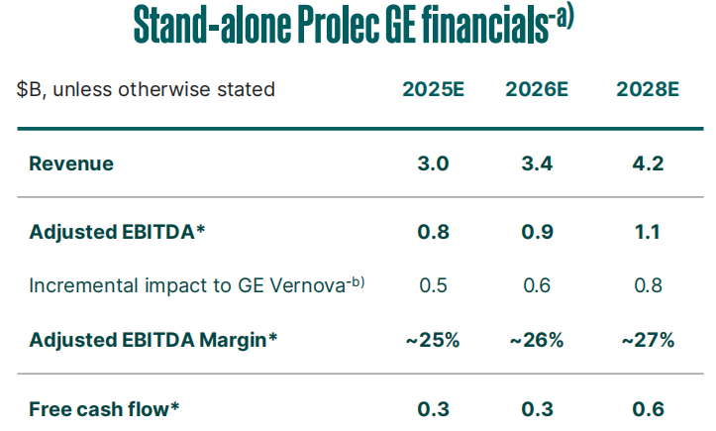
Source: Company, HFI

4.3 Developing and investing in new tech

We beleve GE Vernova is well-positioned to the potential value creator by driving disciplined capex & innovation investments. The company expected the capex and R&D spend in 24 and 25 cumulatively to be ~$4 billion.

GE Vernova focuses on developing and commercializing breakthrough energy technologies. For example, the company is actively positioning its Small Modular Reactor (SMR) business as a significant value creator for the 2030s by heavily investing in technology development, securing robust government and regulatory partnerships, and achieving concrete execution milestones. The strategy is supported by U.S. government , including a $0.4 billion grant for the TVA Clinch River project, and is progressing with the first SMR construction in North America at Ontario Power Generation’s Darlington site. GEV is also expanding the technology commercially in Europe (Poland, Sweden, Finland), demonstrating a clear path from concept to global market deployment.

Other key innovative products are also under development. GE Vernova is expanding investments into artificial intelligence, robotics, and automation. Also, the company is developing in future energy solutions like Carbon Capture, Solid Oxide "X" Fuel Cells (SOXC), and Data Center Solid State Transformers (SSTs), which are long-term plays to address future market needs like decarbonization and data center power demand.

Valuation& recommendation
We estimate that revenue of GE Vernova from year 2025 to 2028 will be $36,938 / 41,553 / 48,460/56,709 million, with the net profit of $ 1,976 / 4,365/ 6,740/ 9,519million. Based on the DCF valuation model, our target price of GE Vernova is $ 862.93, we initiate coverage on the stock with “Outperform”.

Table: DCF Model
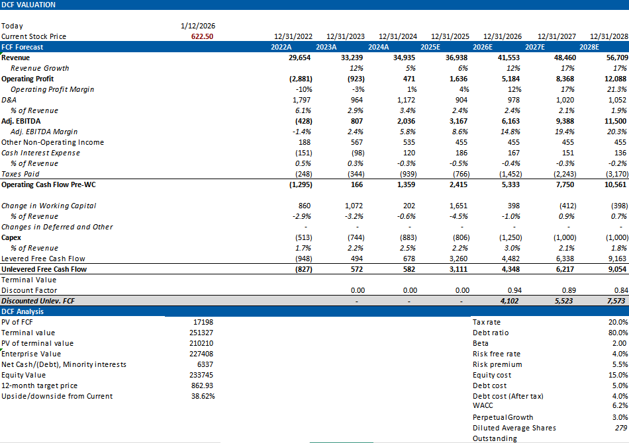

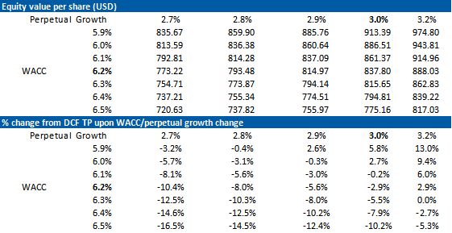
Source: Company, HFI

Table: Financial Summary
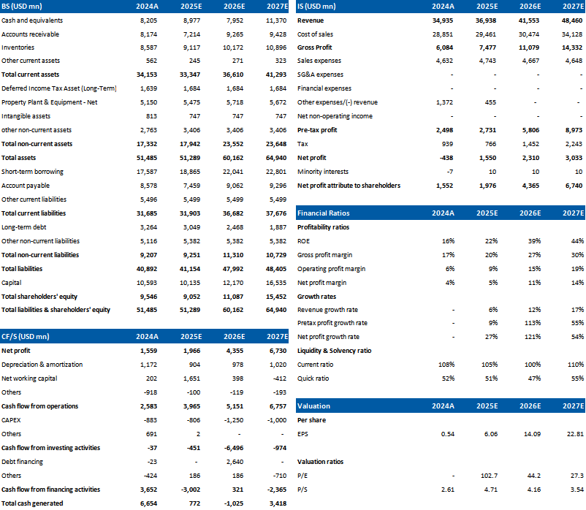
Source: Company, HFI

6. Risks
Electricity demand below expectation; Global decarbonization below expectation;
Changes in the regulatory environment; Emergence of new entrants or technologies with cost-competitive products.

[Table_disclaimer]
附录APPENDIX
重要信息披露
本研究报告由华福国际（香港）金融控股有限公司（下称华福国际）分销，在其许可的司法管辖区内从事证券活动。
IMPORTANT DISCLOSURES
This research report is distributed by HuaFu International (HK) Financial Holdings Limited (referred as HuaFu International below), which is authorized to engage in securities activities in its respective jurisdiction.
分析师认证Analyst Certification:
我， xxxx，在此保证（i）本研究报告中的意见准确反映了我们对本研究中提及的任何或所有目标公司或上市公司的个人观点，并且（ii）我的报酬中没有任何部分与本研究报告中表达的具体建议或观点直接或间接相关；及就此报告中所讨论目标公司的证券，我们（包括我们的家属）在其中均不持有任何财务利益。I, xxxx, certify that (i) the views expressed in this research report accurately reflect my personal views about any or all of the subject companies or issuers referred to in this research and (ii) no part of my compensation was, is or will be directly or indirectly related to the specific recommendations or views expressed in this research report; and that I (including members of my household) have no financial interest in the security or securities of the subject companies discussed.
利益冲突披露Conflict of Interest Disclosures
华福国际及其某些关联公司可从事投资银行业务和/或对本研究中的特定股票或公司进行做市或持有自营头寸。就本研究报告而言，如需了解其中提到的某一公司信息，请发邮件至lcd@hfisec.com.hk）
HuaFu International and some of its affiliates may engage in investment banking and / or serve as a market maker or hold proprietary trading positions of certain stocks or companies in this research report. As far as this research report is concerned, please send an email to lcd@hfisec.com.hk if the information about any company mentioned in this report is needed).
评级定义（从2020年7月1日开始执行）：
华福国际采用相对评级系统来为投资者推荐我们覆盖的公司：优于大市、中性或弱于大市。投资者应仔细阅读华福国际的评级定义。并且华福国际发布分析师观点的完整信息，投资者应仔细阅读全文而非仅看评级。在任何情况下，分析师的评级和研究都不能作为投资建议。投资者的买卖股票的决策应基于各自情况（比如投资者的现有持仓）以及其他因素。
分析师股票评级
优于大市，未来12-18个月内预期相对基准指数涨幅在10%以上，基准定义如下
中性，未来12-18个月内预期相对基准指数变化不大，基准定义如下
弱于大市，未来12-18个月内预期相对基准指数跌幅在10%以上，基准定义如下
各地股票基准指数：日本 – TOPIX, 韩国 – KOSPI, 台湾 – TAIEX, 印度 – Nifty100, 美国 – SP500; 其他所有中国概念股 – MSCI China.
Ratings Definitions (from 1 Jul 2020):
HuaFu International uses a relative rating system using Outperform, Neutral, or Underperform for recommending the stocks we cover to investors. Investors should carefully read the definitions of all ratings used in HuaFu International Research. In addition, since HuaFu International Research contains more complete information concerning the analyst's views, investors should carefully read HuaFu International Research, in its entirety, and not infer the contents from the rating alone. In any case, ratings (or research) should not be used or relied upon as investment advice. An investor's decision to buy or sell a stock should depend on individual circumstances (such as the investor's existing holdings) and other considerations.
Analyst Stock Ratings
Outperform: The stock’s total return over the next 12-18 months is expected to exceed the return of its relevant broad market benchmark by over 10%, as indicated below.
Neutral: The stock’s total return over the next 12-18 months is expected to be in line with the return of its relevant broad market benchmark, as indicated below. Underperform: The stock’s total return over the next 12-18 months is expected to be below the return of its relevant broad market benchmark by over 10%, as indicated below.
Benchmarks for each stock’s listed region are as follows: Japan – TOPIX, Korea – KOSPI, Taiwan – TAIEX, India – Nifty100, US – SP500; for all other China-concept stocks – MSCI China.

华福国际非评级研究：华福国际发布计量、筛选或短篇报告，并在报告中根据估值和其他指标对股票进行排名，或者基于可能的估值倍数提出建议价格。这种排名或建议价格并非为了进行股票评级、提出目标价格或进行基本面估值，而仅供参考使用。
HuaFu International Non-Rated Research: HuaFu International publishes quantitative, screening or short reports which may rank stocks according to valuation and other metrics or may suggest prices based on possible valuation multiples. Such rankings or suggested prices do not purport to be stock ratings or target prices or fundamental values and are for information only.
华福国际A股覆盖：华福国际可能会就中国A股进行覆盖及评级。华福证券，华福国际于福州的母公司，也会于中国发布中国A股的研究报告。但是，华福国际使用与华福证券不同的评级系统，且可能有完全独立的不同研究覆盖团队，所以华福国际与华福证券的中国A股评级、目标价乃至分析逻辑可能有所不同。
HuaFu International Coverage of A-Shares: HuaFu International may cover and rate A-Shares . HuaFu Securities, the ultimate parent company of HuaFu International based in FuZhou, covers and publishes research on these same A-Shares for distribution in mainland China. However, the rating system employed by HuaFu International differs from that used by HuaFu Securites and even the teams covering the same A-share stocks might be totally independently different, as a result there may be a difference in their coverage ratings, target prices and research logics for the same A-share stocks.
重要免责声明：
本报告由华福国际发行，该公司是根据香港证券及期货条例（第571章）持有第4类受规管活动（就证券提供意见）的持牌法团。
本文件所载信息和观点已被编译或源自可靠来源，但华福国际或任何其他属于华福国际的成员对其准确性、完整性和正确性不做任何明示或暗示的声明或保证。本文件中所有观点均截至本报告日期，如有更改，恕不另行通知。本文件仅供参考使用。文件中提及的任何公司或其股票的说明并非意图展示完整的内容，本文件并非/不应被解释为对证券买卖的明示或暗示地出价或征价。在某些司法管辖区，本文件中提及的证券可能无法进行买卖。如果投资产品以投资者本国货币以外的币种进行计价，则汇率变化可能会对投资产生不利影响。过去的表现并不一定代表将来的结果。某些特定交易，包括设计金融衍生工具的，有产生重大风险的可能性，因此并不适合所有的投资者。您还应认识到本文件中的建议并非为您量身定制。分析师并未考虑到您自身的财务情况，如您的财务状况和风险偏好。因此您必须自行分析并在适用的情况下咨询自己的法律、税收、会计、金融和其他方面的专业顾问，以期在投资之前评估该项建议是否适合于您。若由于使用本文件所载的材料而产生任何直接或间接的损失，华福国际及其董事、雇员或代理人对此均不承担任何责任。
除对本文内容承担责任的分析师除外，华福国际及我们的关联公司、高级管理人员、董事和雇员，均可不时作为主事人就本文件所述的任何证券或衍生品持有长仓或短仓以及进行买卖。华福国际的销售员、交易员和其他专业人士均可向华福国际的相关客户和公司提供与本文件所述意见相反的口头或书面市场评论意见或交易策略。华福国际可做出与本文件所述建议或意见不一致的投资决策。但华福国际没有义务来确保本文件的收件人了解到该等交易决定、思路或建议。
请访问华福国际网站 www.hfisec.com.hk ，查阅更多有关华福国际为预防和避免利益冲突设立的组织和行政安排的内容信息。
IMPORTANT DISCLAIMER
The research report is issued by HuaFu International, a licensed corporation to carry on Type 4 regulated activity (advising on securities) for the purpose of the Securities and Futures Ordinance (Cap. 571) of Hong Kong.
The information and opinions contained in this research report have been compiled or arrived at from sources believed to be reliable and in good faith but no representation or warranty, express or implied, is made by HuaFu International or any other related members from which this research report may be received, as to their accuracy, completeness or correctness. All opinions expressed herein are as of the date of this research report and are subject to change without notice. This research report is for information purpose only. Descriptions of any companies or their securities mentioned herein are not intended to be complete and this research report is not, and should not be construed expressly or impliedly as, an offer to buy or sell securities. The securities referred to in this research report may not be eligible for purchase or sale in some jurisdictions. If an investment product is denominated in a currency other than an investor's home currency, a change in exchange rates may adversely affect the investment. Past performance is not necessarily indicative of future results. Certain transactions, including those involving derivatives, give rise to substantial risk and are not suitable for all investors. You should also bear in mind that recommendations in this research report are not tailor-made for you. The analyst has not taken into account your unique financial circumstances, such as your financial situation and risk appetite. You must, therefore, analyze and should, where applicable, consult your own legal, tax, accounting, financial and other professional advisers to evaluate whether the recommendations suits you before investment. Neither HuaFu International nor any of its directors, employees or agents accepts any liability whatsoever for any direct or consequential loss arising from any use of the materials contained in this research report.
HuaFu International and its affiliates, officers, directors, and employees, excluding the analysts responsible for the content of this document, will from time to time have long or short positions in, act as principal in, and buy or sell, the securities or derivatives, if any, referred to in this research report. Sales, traders, and other professionals of HuaFu International may provide oral or written market commentary or trading strategies to the relevant clients and the companies within HuaFu International that reflect opinions that are contrary to the opinions expressed in this research report. HuaFu Internatioal may make investment decisions that are inconsistent with the recommendations or views expressed in this research report. HuaFu International is under no obligation to ensure that such other trading decisions, ideas or recommendations are brought to the attention of any recipient of this research report.
Please refer to XXX’s website www.hfisec.com.hk for further information on HuaFu International’s organizational and administrative arrangements set up for the prevention and avoidance of conflicts of interest with respect to Research.

分发和地区通知：
除非下文另有规定，否则任何希望讨论本报告或者就本项研究中讨论的任何证券进行任何交易的收件人均应联系其所在国家或地区的华福国际销售人员。
香港投资者的通知事项：华福国际负责分发该研究报告，华福国际是在香港有权实施第1类受规管活动（从事证券交易）的持牌公司。该研究报告并不构成《证券及期货条例》（香港法例第571章）（以下简称“SFO”）所界定的要约邀请，证券要约或公众要约。本研究报告仅提供给SFO所界定的“专业投资者”。本研究报告未经过证券及期货事务监察委员会的审查。您不应仅根据本研究报告中所载的信息做出投资决定。本研究报告的收件人就研究报告中产生或与之相关的任何事宜请联系华福国际销售人员。
DISTRIBUTION AND REGIONAL NOTICES
Except as otherwise indicated below, any Recipient wishing to discuss this research report or effect any transaction in any security discussed in HuaFu International’s research should contact the HuaFu International salesperson in their own country or region.
Notice to Hong Kong investors: The research report is distributed by HuaFu International, which is a licensed corporation to carry on Type 1 regulated activity (dealing in securities) in Hong Kong. This research report does not constitute a solicitation or an offer of securities or an invitation to the public within the meaning of the SFO. This research report is only to be circulated to "Professional Investors" as defined in the SFO. This research report has not been reviewed by the Securities and Futures Commission. You should not make investment decisions solely on the basis of the information contained in this research report. Recipients of this research report are to contact HuaFu International salespersons in respect of any matters arising from, or in connection with, the research report.

中华人民共和国的通知事项：在中华人民共和国（下称“中国”，就本报告目的而言，不包括香港特别行政区、澳门特别行政区和台湾）只有根据适用的中国法律法规而收到该材料的人员方可使用该材料。并且根据相关法律法规，该材料中的信息并不构成“在中国从事生产、经营活动”。本文件在中国并不构成相关证券的公共发售或认购。无论根据法律规定或其他任何规定，在取得中国政府所有的批准或许可之前，任何法人或自然人均不得直接或间接地购买本材料中的任何证券或任何实益权益。接收本文件的人员须遵守上述限制性规定。
本项研究仅供收件人使用，未经华福国际的书面同意不得予以复制和再次分发。
版权所有：华福国际2025年。保留所有权利。
People’s Republic of China (PRC): In the PRC, the research report is directed for the sole use of those who receive the research report in accordance with the applicable PRC laws and regulations. Further, the information on the research report does not constitute "production and business activities in the PRC" under relevant PRC laws. This research report does not constitute a public offer of the security, whether by sale or subscription, in the PRC. Further, no legal or natural persons of the PRC may directly or indirectly purchase any of the security or any beneficial interest therein without obtaining all prior PRC government approvals or licenses that are required, whether statutorily or otherwise. Persons who come into possession of this research are required to observe these restrictions.
This research report is intended for the recipients only and may not be reproduced or redistributed without the written consent of an authorized signatory of HuaFu International.
Copyright: HuaFu International 2025. All rights reserved

Recommendation Chart
[Table_RecommendationChart]
Source: Company data Bloomberg, XXX estimates

